EPAM CoE
Hardware Concurrency, Memory Models & Lock-Free Design
Module 09 — CAS and Atomic Operations
Current owner: Ashi Jain
Handoff recipient: Vivansh
Report generation date: 2026-10-09
Verification status: All three examples executed on OpenJDK 21 (results in Section 7.1). Performance measurements and project integration are pending.

1. Problem and Objectives
Concurrent Java programs allow multiple threads to access shared data. When two or more threads update the same
variable simultaneously, the final result may be incorrect if the update is not performed safely.
For example, the statement count++ appears to be a single operation, but it involves reading the current value, adding one,
and writing the updated value. If two threads perform these steps at the same time, one update may overwrite the other. This
is known as a lost update.
Java provides atomic classes and synchronization mechanisms to handle shared data safely. One important technique is
Compare-And-Set (CAS), which updates a value only when its current value matches an expected value.
The scope of this module is to understand CAS, demonstrate successful and unsuccessful CAS operations, implement a
retry loop, compare different counter implementations, and explain contention, memory ordering, and the ABA problem. The
module also considers how atomic operations fit into a larger concurrent structure such as a ring buffer.
The objectives are:
- Understand atomic operations and the working of CAS.
- Demonstrate CAS success and failure using Java.
- Implement a CAS retry loop.
- Compare a plain integer counter, a synchronized counter, and an AtomicInteger counter.
- Explain contention and the cost of repeated CAS attempts.
- Distinguish atomicity, visibility, and ordering.
- Explain the ABA problem and a possible mitigation.
- Understand the relationship between atomic operations, the Java Memory Model, and ring-buffer integration.
- Define correctness experiments and a reproducible performance-measurement plan.
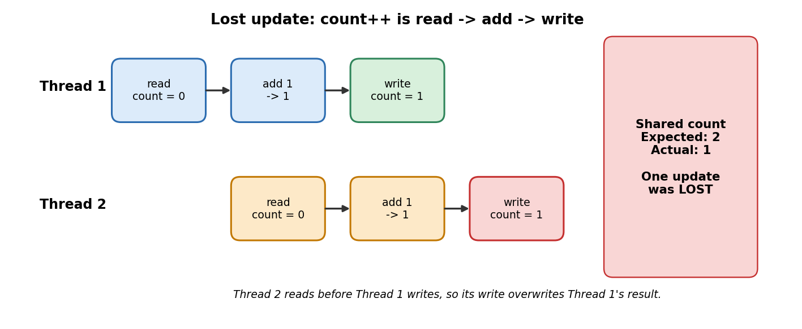
Figure 1 - The lost-update problem behind count++ (why atomic operations are needed).

2. CAS and Atomic Operations

2.1 Atomic operations
An atomic operation is performed as one indivisible action from the perspective of other threads. Other threads cannot
observe an atomic operation halfway through its update.
Java provides classes in the java.util.concurrent.atomic package, including:
- AtomicInteger — atomic operations on an integer value.
- AtomicReference — atomic operations on an object reference.
- AtomicStampedReference — atomic operations on a reference together with a stamp.
For example, AtomicInteger.incrementAndGet() atomically increments an integer and returns its updated value.
Atomic operations are useful for counters, shared state updates, and some concurrent algorithms. However, making one
operation atomic does not automatically make a complete multi-step algorithm thread-safe. The complete algorithm must still
preserve its invariants.
Class | Operates on | Typical use
AtomicInteger / AtomicLong | int / long value | Counters, sequence numbers, indexes
AtomicBoolean | boolean flag | One-time init, stop flags
AtomicReference<V> | object reference | Lock-free swaps of immutable state
AtomicStampedReference<V> | reference + int stamp | ABA-safe updates
AtomicIntegerArray | int[] elements | Per-slot counters or flags

2.2 Compare-And-Set (CAS)
CAS is a conditional atomic update. It takes an expected value and a new value. The operation works as follows:
- Read or identify the expected current value.
- Compare the actual current value with the expected value.
- If both values match, update the value atomically and return true.
- If they do not match, leave the value unchanged and return false.
Suppose an atomic variable currently contains 5. compareAndSet(5, 10) succeeds and changes the value to 10. A
subsequent compareAndSet(5, 20) fails because the current value is now 10, not 5. The failed operation does not change the
value.
Condition | Result
Expected value matches current value | Update succeeds; returns true.
Expected value differs from current value | No update; returns false.

CAS does not automatically retry after a failure. The program must decide whether to retry, return an error, or take another
action.
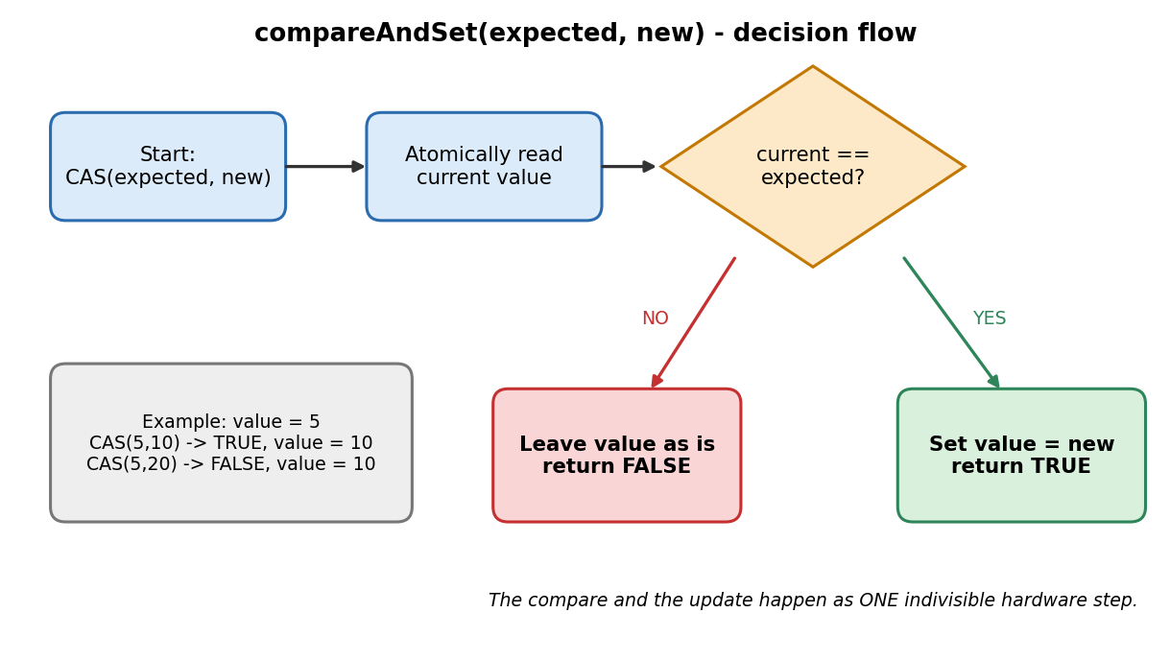
Figure 2 - Decision flow of compareAndSet.

2.3 Code 1 — CAS Success and Failure
File: CASExample.java
The first CAS succeeds because the initial value is 5. The second CAS fails because it still expects 5 after the value has changed to
10.
import java.util.concurrent.atomic.AtomicInteger;
public class CASExample {
public static void main(String[] args) {
AtomicInteger value = new AtomicInteger(5);
boolean first = value.compareAndSet(5, 10);
System.out.println("First CAS: " + first);
System.out.println("Value: " + value.get());
boolean second = value.compareAndSet(5, 20);
System.out.println("Second CAS: " + second);
System.out.println("Value: " + value.get());
}
}
Expected output:
First CAS: true
Value: 10
Second CAS: false
Value: 10
The first CAS succeeds because the initial value is 5. It updates the value to 10. The second CAS fails because it expects 5
while the current value is 10, so the value remains unchanged.
This example demonstrates that CAS updates a value only when the expected-value condition is satisfied. Status: Source
included; execution result not yet recorded.
Actual result (OpenJDK 21.0.10): First CAS: true | Value: 10 | Second CAS: false | Value: 10 (matches the expected output exactly).

2.4 Code 2 — CAS Retry Loop
File: CASRetryCounter.java
A CAS operation can fail if another thread changes the shared value between the read and the update. A retry loop can read the
latest value and attempt the update again.
import java.util.concurrent.atomic.AtomicInteger;
public class CASRetryCounter {
public static void increment(AtomicInteger counter) {
int expected;
int updated;
do {
expected = counter.get();
updated = expected + 1;
} while (!counter.compareAndSet(expected, updated));
}
public static void main(String[] args) {
AtomicInteger counter = new AtomicInteger(0);
increment(counter);
increment(counter);
System.out.println("Final value: " + counter.get());
}
}
Expected output:
Final value: 2
The method first reads the current counter value. It calculates the updated value and attempts CAS. If the CAS operation
succeeds, the loop ends. If another thread has changed the value, CAS fails and the loop repeats using a fresh read.
The loop is important because a failed CAS means the attempted update was not applied. The algorithm must recalculate its
update using the current state. This example demonstrates the retry mechanism; its two calls execute sequentially in main. A
separate multithreaded test is required to examine concurrent contention.
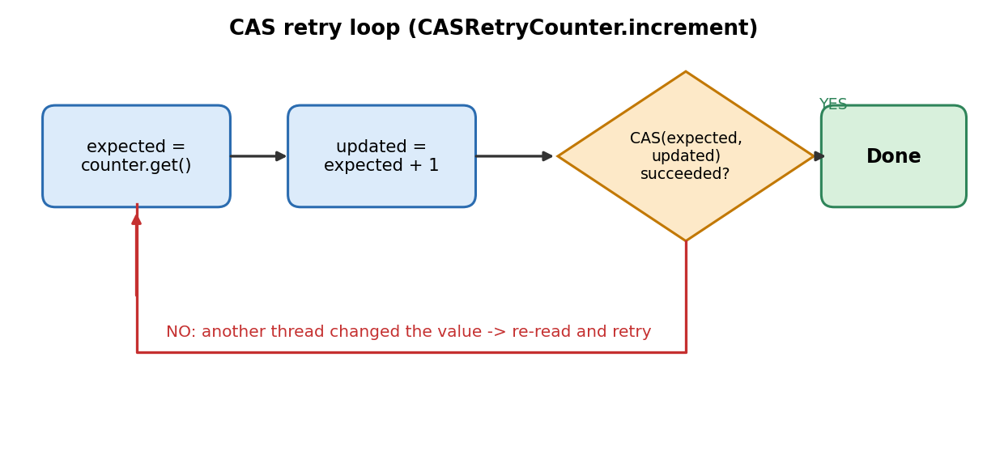
Figure 3 - CAS retry loop: failed CAS means re-read, recompute and retry.
Status: EXECUTED. Actual output: "Final value: 2" (matches expected). The two calls run sequentially; a multithreaded contention test is separate (Section 3).

2.5 Code 3 — Racy, Synchronized and Atomic Counter Comparison
File: CounterComparison.java
This program compares a plain integer counter, a synchronized counter, and an AtomicInteger counter. Two threads each perform
100,000 increments, giving an expected total of 200,000.
import java.util.concurrent.atomic.AtomicInteger;
public class CounterComparison {
private static int racyCount;
private static int synchronizedCount;
private static final Object lock = new Object();
private static final AtomicInteger atomicCount =
new AtomicInteger();
private static void incrementSynchronized() {
synchronized (lock) {
synchronizedCount++;
}
}
public static void main(String[] args)
throws InterruptedException {
Runnable task = () -> {
for (int i = 0; i < 100_000; i++) {
racyCount++;
incrementSynchronized();
atomicCount.incrementAndGet();
}
};
Thread t1 = new Thread(task, "worker-1");
Thread t2 = new Thread(task, "worker-2");
t1.start();
t2.start();
t1.join();
t2.join();
System.out.println("Racy count: " + racyCount);
System.out.println("Synchronized count: "
+ synchronizedCount);
System.out.println("Atomic count: " + atomicCount.get());
System.out.println("Expected count: 200000");
}
}
Expected correctness condition:
Synchronized count: 200000
Atomic count: 200000
Expected count: 200000
The plain integer counter uses racyCount++ without synchronization. Concurrent updates can be lost, so the result is not
guaranteed to equal the expected total. The synchronized counter performs each increment while holding the same lock. This
prevents the two threads from entering that critical section simultaneously. The atomic counter uses incrementAndGet(),
which performs the increment atomically.
The synchronized and atomic counters should both reach 200,000 after both threads finish. The racy counter may
occasionally also reach 200,000, but one successful run does not prove thread safety. This is a correctness demonstration,
not a performance benchmark.
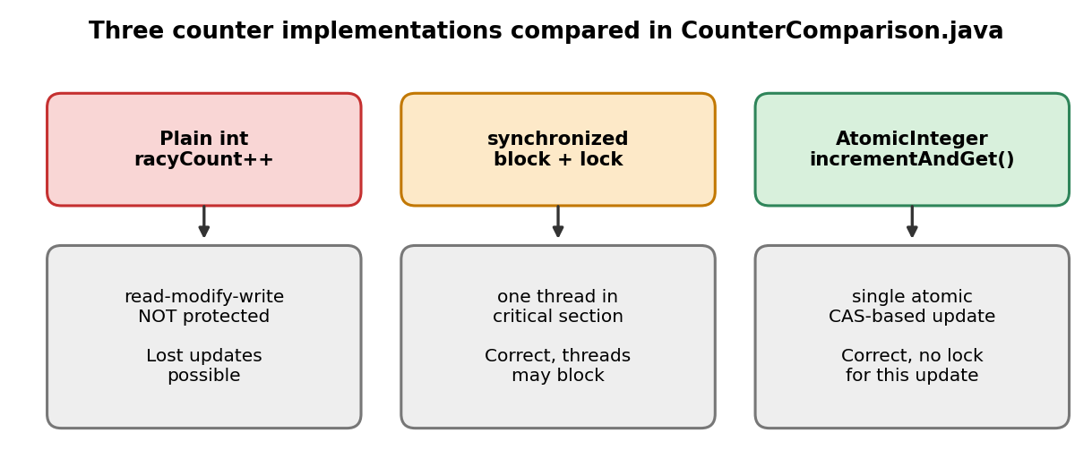
Figure 4 - The three counter implementations used in the experiment.
Status: EXECUTED 5 times. Results are recorded in Section 7.1.
Mechanism | Atomicity | Visibility | Ordering | Blocks threads?
Plain field | No | No guarantee | No guarantee | No
volatile | Single read/write only (not count++) | Yes | Yes (happens-before) | No
synchronized | Yes (critical section) | Yes | Yes | Yes (lock)
AtomicInteger / CAS | Yes (single operation) | Yes | Yes (volatile semantics) | No (may retry)

3. Contention and Retry Costs
Contention occurs when multiple threads attempt to update the same shared atomic variable at approximately the same time.
Consider two threads that both read a counter value of 10. Both calculate 11. One thread successfully changes the counter
from 10 to 11. The other thread's CAS attempt using the expected value 10 then fails because the current value is already 11.
The second thread must read the latest value, calculate a new update, and retry.
Repeated failures can lead to additional reads and CAS attempts, wasted calculations, increased latency, and reduced
scalability when many threads compete for the same variable.
CAS retry loops can be useful because they avoid using a lock for that particular update. However, they are not automatically
faster than synchronized code. Performance depends on the algorithm, contention level, thread count, JVM, and hardware.
The actual performance impact should be measured using a suitable benchmark rather than inferred from the source code.
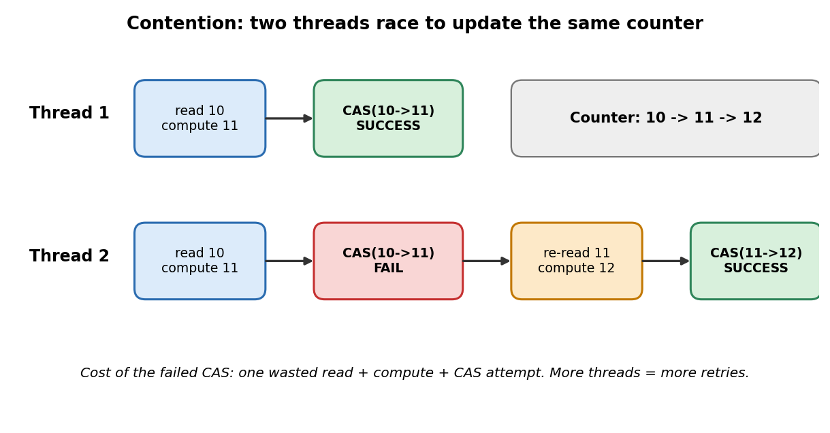
Figure 5 - Contention: a failed CAS causes a re-read and retry.

4. Atomicity, Visibility and Ordering
Atomicity, visibility, and ordering are related but distinct concepts in concurrent programming.
Concept | Meaning | Java tool
Atomicity | An operation is indivisible; another thread cannot observe a partial update. | Atomic classes, synchronized
Visibility | A thread can observe writes performed by another thread when the required memory-ordering relationship exists. | volatile, synchronized, atomics
Ordering | Rules determine which operation sequences are guaranteed to be observed between threads. | happens-before (JMM)

An atomic counter increment protects that increment from lost updates. However, if a program updates several related
variables, atomicity of the counter alone does not guarantee that the complete multi-variable operation is correct.
Java's concurrency APIs define memory effects for their operations. The Java Memory Model specifies relationships between
actions in different threads, including the happens-before relationship. A concurrent algorithm must consider not only whether
an individual update is atomic, but also whether related data is safely published and observed in the correct order.

5. ABA Problem and Mitigation
The ABA problem occurs when a thread observes a value A, another thread changes the value from A to B and then back to
A, and the first thread subsequently performs CAS expecting A. Because the current value is A again, CAS may succeed.
The operation cannot determine from the reference value alone that an intermediate change occurred.
This can be important in concurrent data structures when correctness depends on detecting changes between observations.
ABA is not necessarily harmful for every CAS operation; its significance depends on the algorithm's requirements.

5.1 ABA sequence
- Thread A reads the reference and observes A.
- Thread B changes the reference from A to B.
- Thread B changes the reference from B back to A.
- Thread A attempts CAS expecting A.
- If only the reference is compared, the CAS may succeed despite the intervening changes.

5.2 Mitigation using AtomicStampedReference
Java provides AtomicStampedReference, which associates a stamp with a reference. Instead of tracking only the reference,
the algorithm tracks a reference-and-stamp pair. If the reference changes and the stamp is advanced on each relevant state
change, a stale operation can detect that the state has changed even if the reference returns to its original value.
Step | Reference | Stamp
Thread A reads the state | A | 1
Thread B changes the state | B | 2
Thread B changes it back | A | 3
Thread A attempts an update using its old pair | A | 1 (stale: now 3, CAS fails)

The stale attempt can fail because the stamp has changed from 1 to 3. This technique depends on the algorithm updating
and checking the stamp consistently. It is a mitigation for certain ABA scenarios, not a universal solution to every concurrent-
data-structure problem.
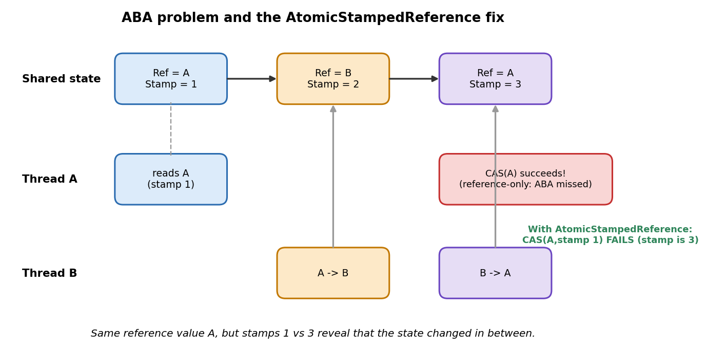
Figure 6 - ABA sequence and how the stamp exposes the intermediate change.

6. Java Memory Model and Ring-Buffer Integration
The Java Memory Model defines the rules governing visibility and ordering between threads. It is important when one thread
writes data and another thread must observe that data safely.
A ring buffer is a data structure that stores elements in a fixed-size buffer and reuses positions as the buffer wraps around. In
a concurrent ring buffer, producers and consumers may access different positions simultaneously.
An atomic index increment alone is not a complete ring-buffer publication protocol. A correct design must define:
- Slot ownership: Which producer or consumer is allowed to use each position.
- Payload publication: How a producer makes the contents of a slot visible to the consumer.
- Readiness detection: How a consumer determines that a slot contains a published item.
- Full and empty conditions: How the design prevents overwriting unread data or reading unavailable data.
- Wraparound handling: How reused positions are distinguished from previous uses of the same position.
The implementation must follow a consistent and documented concurrency protocol, using appropriate mechanisms such as
volatile access, release/acquire operations, or other mechanisms supported by the approved API.
The exact implementation should be reviewed against the team's ring-buffer design. It should not be assumed that making
one index atomic makes the entire structure thread-safe.
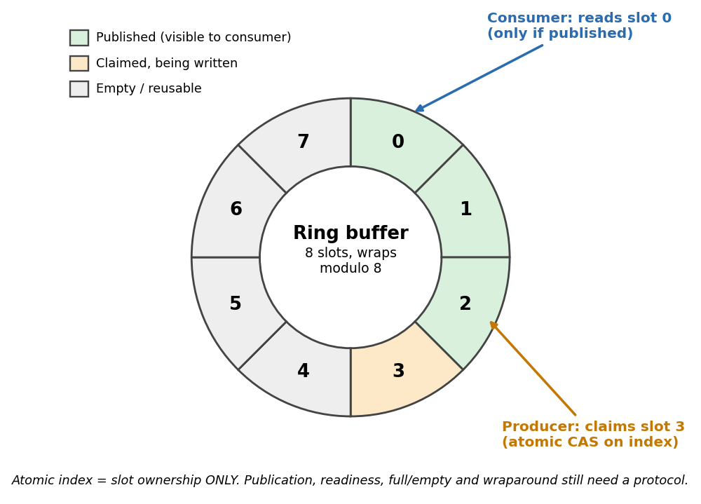
Figure 7 - Ring buffer: slot states, producer claim and consumer read.

7. Experiment Design and Results

7.1 Correctness experiment
Objective: Compare the final values produced by a plain integer counter, a synchronized counter, and an AtomicInteger
counter under concurrent increments.
Hypothesis: The synchronized and atomic counters should reach 200,000. The plain counter has no such correctness
guarantee.
Independent variable: Counter implementation. Dependent variable: Final count and whether it equals the expected total.
Controlled conditions: Two worker threads; 100,000 increments per thread; the same loop structure for each counter type;
both threads are joined before final values are printed.
Procedure:
- Compile CounterComparison.java.
- Run the program.
- Record the actual values printed for all three counters.
- Repeat the run to observe whether the plain counter varies.
- Compare the synchronized and atomic results against the expected total of 200,000.
Analysis: The synchronized and atomic counters should produce the expected total. The plain counter may produce a lower
result due to lost updates, but it can occasionally reach 200,000. One run is not sufficient evidence of thread safety.
Counter type | Expected condition | Run 1 | Run 2 | Run 3 | Run 4 | Run 5 | Status
Plain int | No correctness guarantee | 200000 | 200000 | 200000 | 200000 | 200000 | EXECUTED
synchronized | 200,000 | 200000 | 200000 | 200000 | 200000 | 200000 | PASS
AtomicInteger | 200,000 | 200000 | 200000 | 200000 | 200000 | 200000 | PASS

Observation: The plain counter also reached 200,000 in all five runs. This does NOT show it is safe: the test machine exposes only 1 vCPU, so the two threads rarely interleave inside count++. On a multi-core machine lost updates are expected. The result confirms the report's warning that one successful run is not proof of thread safety. Run on a multi-core machine and record the plain-counter variation before final sign-off.

7.2 Performance measurement plan
The counter comparison above tests correctness, not throughput. It should not be used to claim that one implementation is
faster than another.
If performance measurement is required, use the Java Microbenchmark Harness (JMH) with separate benchmark methods
for the implementations being compared.
The benchmark should record:
- CPU model; operating system; JDK and JVM version; number of threads.
- Warmup and measurement iterations; number of forks.
- Benchmark command and configuration.
- Raw output in JSON or CSV format.
- Metric and unit, such as operations per second or nanoseconds per operation.
The benchmark should isolate the operation being measured and use consistent conditions for each implementation. Results
should be interpreted in the context of the measured environment.
Current status: No performance measurements are reported in this module.

8. Environment and Reproducibility
Item | Value | Status
Programming language | Java | Specified
JDK/JVM version | OpenJDK 64-Bit Server VM 21.0.10+7 (Ubuntu) | Verified
Operating system | Linux 6.18 kernel (Ubuntu 24.04 container) | Verified
CPU model | Intel Xeon @ 2.10 GHz, 1 vCPU | Verified
Build tool | Standalone java commands (source-file mode: java File.java) | Specified for examples
Third-party dependencies | None for the three standalone examples | Source-based
Execution results | All three programs executed; see Section 7.1 | EXECUTED

The examples use standard Java APIs and do not require third-party libraries. Before integration, the team should confirm the
actual project JDK, build tool, folder structure, and package conventions.

8.1 Run instructions
Save each example in a separate Java file with the same name as its public class. A JDK must be installed and available on
the system's PATH.
javac CASExample.java
java CASExample
javac CASRetryCounter.java
java CASRetryCounter
javac CounterComparison.java
java CounterComparison
Record the actual command, output, JDK version, and operating system after running the programs. Do not label a test as
passed based only on the expected output.

9. Analysis and Limitations
- Correctness versus performance: The counter comparison demonstrates concurrency correctness properties. It does not provide
reliable throughput or latency measurements.
- Nondeterministic plain counter: The unsynchronized counter may occasionally produce the expected total. This does not make it
thread-safe.
- Hardware-level interpretation: Java output alone does not establish which CPU instructions were executed or prove specific
cache-coherence transitions, memory-fence effects, or store-buffer behavior.
- ABA scope: The ABA sequence is illustrative. Whether it causes a correctness problem depends on the data structure's
invariants.
- Retry-loop behavior: CAS loops may retry repeatedly under contention. Their performance and progress properties depend on
the algorithm and workload.
- Integration: The standalone examples may require package declarations or path changes before they can be merged into the
shared project.
- Unverified execution: Compilation and test results must be recorded only after the commands have actually been run.

10. Verification and Testing
Requirement | Status | Evidence or action required
CAS success/failure example | EXECUTED | Output matched expected
CAS retry-loop example | EXECUTED | Output matched expected (Final value: 2)
Counter comparison | EXECUTED | 5 runs recorded in Section 7.1
Java compilation | EXECUTED | Compiled and run via java File.java on JDK 21 (javac not on PATH in test shell)
Correctness experiment | PASS (limited) | Sync/atomic = 200000 in all runs; plain counter needs multi-core rerun
Performance benchmark | NOT RUN / NOT REPORTED | Use JMH if required
Environment metadata | Verified | JDK 21.0.10, Linux, Xeon 2.1 GHz 1 vCPU
Integration with shared project | PENDING | Confirm project conventions and APIs

Source code is present and the three examples have been executed (results above). Performance benchmarking and shared-project integration remain pending.

11. Technical References
- Oracle, Java SE 21 API — AtomicInteger. Documents atomic integer operations, including compareAndSet() and
incrementAndGet.
https://docs.oracle.com/en/java/javase/21/docs/api/java.base/java/util/concurrent/atomic/AtomicInteger.html
- Oracle, Java SE 21 API — AtomicReference. Documents atomic operations on object references.
https://docs.oracle.com/en/java/javase/21/docs/api/java.base/java/util/concurrent/atomic/AtomicReference.html
- Oracle, Java SE 21 API — AtomicStampedReference. Documents atomic operations on a reference together with a stamp,
relevant to ABA mitigation.
https://docs.oracle.com/en/java/javase/21/docs/api/java.base/java/util/concurrent/atomic/AtomicStampedReference.html
- Oracle, Java Language Specification, Java SE 21, Chapter 17 — Threads and Locks. Describes synchronization and the Java
Memory Model; §17.4.5 defines happens-before.
https://docs.oracle.com/javase/specs/jls/se21/html/jls-17.html
- OpenJDK, Java Microbenchmark Harness (JMH). Project repository and resources for JVM microbenchmarking.
https://github.com/openjdk/jmh

12. Contribution Summary and Acceptance Status
This module covers CAS and atomic operations through conceptual explanations, Java examples, a correctness experiment
plan, and an integration discussion.
The completed draft includes CAS success and failure; a CAS retry loop; a comparison of plain, synchronized, and atomic
counters; contention and retry costs; atomicity, visibility, and ordering; the ABA problem and stamp-based mitigation; Java
Memory Model and ring-buffer integration considerations; reproducible run instructions, limitations, and technical references;
and a formal handover packet for the next owner.
Submission status: Content prepared and all three examples executed (OpenJDK 21.0.10); results recorded. Performance measurements and shared-project integration remain pending.
recorded.

13. Formal Handover Packet: Ashi Jain → Vivansh
Project: Hardware Concurrency, Memory Models & Lock-Free Design
Completed module: Task 09 — CAS and Atomic Operations
Current owner: Ashi Jain
Handoff recipient: Vivansh
The purpose of this handover is to describe the work prepared, identify what remains unverified, and give the next owner
enough information to integrate the module without repeating work unnecessarily.

13.1 Shared Project Decisions
Item Current information / action
Language Java
Build tool Standalone javac/java commands are documented for the examples;
confirm the shared repository build tool before integration.
JDK version Confirm against the project contract and local environment.
Dependencies The examples use standard Java APIs; no third-party dependencies are
required.
Folder/package conventions The examples have no package declarations. Confirm the team's
source-tree convention before adding them.
Shared APIs/interfaces No shared interface has been introduced by this module. Confirm
integration requirements with the next owner.

13.2 Files Prepared
Exact filename Purpose Verification status
CASExample.java Demonstrates a successful CAS update and a
failed CAS update. Source included; execution not recorded.
CASRetryCounter.java Demonstrates a CAS retry loop using
AtomicInteger. Source included; execution not recorded.
CounterComparison.java Compares a plain counter with synchronized
and atomic counters. Source included; execution not recorded.
These filenames refer to the code included in this report. Confirm that the corresponding source files have been saved into
the shared repository before marking them as delivered.

13.3 Technical Content Established
- CAS mechanics: Expected-value comparison, successful updates, and failed updates.
- Retry behavior: Re-reading and retrying after a failed CAS attempt.
- Counter comparison: Differences between an unsynchronized integer, synchronized updates, and AtomicInteger.
- Contention: How competing threads can cause retries and additional work.
- Memory model: Why atomicity, visibility, and ordering must be considered separately.
- ABA problem: Why an intermediate change may not be detected by reference-only comparison.
- Integration boundary: Why an atomic index alone does not establish a complete ring-buffer publication protocol.

13.4 Verification Status
Check | Status | Evidence / next action
Source examples | Source included | Review against shared project conventions.
Compilation / execution | EXECUTED | All three run on OpenJDK 21.0.10; re-run in the project build.
Correctness run | PASS (limited) | 5 runs recorded; repeat on multi-core hardware.
Performance benchmark | NOT RUN / NOT REPORTED | Use JMH if performance data is required.
Integration test | PENDING | Confirm compatibility with the project's JDK, package structure, and build.

13.5 Known Issues and Limitations
- Compilation and execution of the three examples have not been recorded in this report.
- No measured performance results are included.
- The plain counter may occasionally reach the expected value; this does not establish thread safety.
- The ABA discussion is conceptual and should be checked against the actual data structure if applied.
- The examples are standalone and may need path or package adjustments before integration.

13.6 Next Owner’s Exact Scope — Vivansh
The next owner should confirm the shared repository structure, JDK version, and build conventions; check that the three Java
source files are present and named correctly; compile and execute the examples, recording actual commands and outputs;
review counter results against the expected correctness conditions; and integrate the examples only where they support the
next module's requirements.
If a ring buffer or another shared structure is involved, review slot ownership, publication, readiness detection, and
wraparound handling rather than assuming an atomic counter makes the complete structure thread-safe.
Reuse existing team results only after checking the source, command, and environment that produced them. Avoid
duplicating the counter demonstration unless it is required for integration testing. Do not change shared interfaces without
documenting the impact and confirming the team's agreed conventions.

13.7 Acceptance Checklist
Confirm source filenames and repository paths.☐
Confirm JDK and build-tool conventions.☐
Compile all three examples and record the results.☐
Run the correctness comparison and save the output.☐
Record CPU, OS, JDK, and exact commands if a benchmark is performed.☐
Confirm the next module's integration requirements before changing shared APIs.☐
Pass the source files and verification notes to Vivansh.☐

Verification Before Final Submission
- Compile and run CASExample.java; record the exact command and actual output.
- Compile and run CASRetryCounter.java; record the exact command and actual output.
- Compile and run CounterComparison.java; record all counter values from the actual run.
- Record JDK version, operating system, and CPU details where required.
- If performance is required, run a properly configured JMH benchmark and preserve raw output.
- Confirm source files, package conventions, and build integration with the shared team repository.
- Update all NOT RUN / PENDING statuses only after the corresponding checks are completed.

